tablThis is a sample of the resources Legato Strategic Consulting provides through dedicated support to institutions like yours.

How to Update an EIB

Use this guide to avoid EIB failure by keeping templates up-to-date.

In this guide, you will learn:
- Basic introduction to the EIB and EIB Template
- Impacts of outdated EIBs
- Solutions to keep EIBs updated

Note: Screenshots for this guide are taken from the Submit Course Section EIB.

ABOUT ENTERPRISE INTERFACE BUILDER (EIB) TEMPLATES

An EIB (Enterprise Interface Builder) is a tool in Workday that helps you move data in or out of the system, like a smart import/export feature. You can use it to upload or download large sets of data without doing it all by hand, which saves time and reduces errors.
An EIB template is a pre-made spreadsheet or file format that lays out what data Workday expects (like column names and structure). You use it to make sure you're sending the right info into Workday in the right way.

CHALLENGE
EIB templates can become outdated if the system changes (for example, if fields are added or renamed). Before importing data, always double-check you are using the most up-to-date version. The more time since the EIB template’s last update, the more likely it will fail.
Time Since Last Update | Likelihood of EIB Failure | Notes
0-6 Months | Low | Generally stable unless BP or security changed.
6-12 Months | Moderate | One major Workday release could have introduced breaking changes.
12+ Months | High | Multiple releases may have deprecated fields or changed behaviors.

UPDATE A EIB TEMPLATE MODEL
- Locate your EIB Template and View Integration System
- Enter “INTSYS: [EIB name]”
- Locate and view the report with all your integration systems. Note: This should contain the date of last update to help determine whether a new update is needed)
- Click “Related Actions”
- Click “Template Model”
- Click “View”

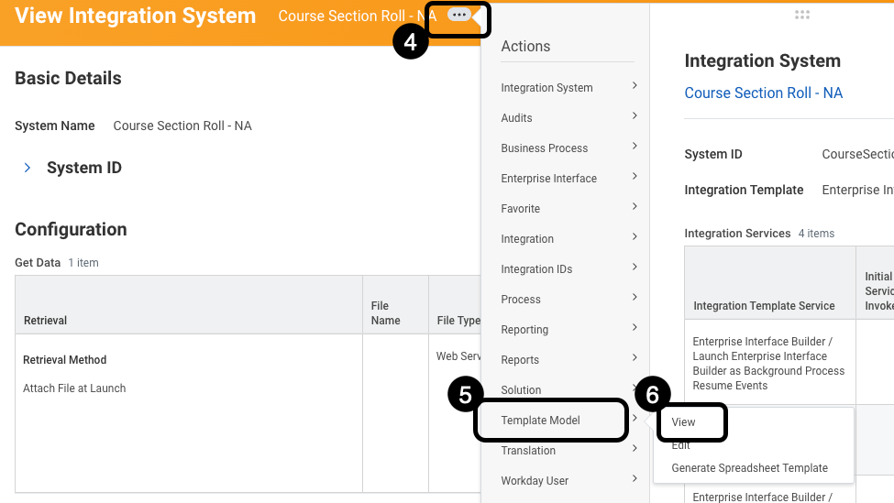

- The View Template Model page will open. To generate a new, updated default template model click “Related Actions”
- Click “Template Model”
- Click “Generate Default Template Model”

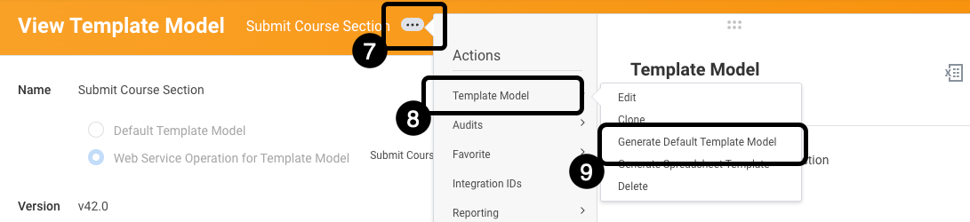

- Click “OK”.

Your version is now updated.

